

Zerto Sites Installation  
& Config Summary, 2024

**For   
LA County Office of Education  
(ERP Dept)**

**Presented By:**

Jason Walker

Senior Solutions Engineer

Jason.Walker@Nth.com

January 7, 2025

Table of Contents

Introduction 3

1. Zerto Topology Overview 3

2. Installation & Configuration Details 8

a. Zerto Site Managers (ZVM) & Replication Appliances (Z-VRA) 9

b. Zerto Site Component Maps 13

c. Virtual Protection Groups (VPG) 15

d. Next Steps for LACOE: A Call-to-Action Summary 18

3. Reference Links 19

4. Zerto Glossary 20

**Table & Figure References:**

Table 1: Zerto Component Networking Assignments 9

Figure 1: Zerto Basic Topology 3

Figure 2: Overall Zerto ERP Site Topology 8

Figure 3: Zerto Site Dashboard 12

Figure 4: VRA Setup Dashboard 12

Figure 5: Production Site Zerto Map 13

Figure 6: DR Site Zerto Map 14

Figure 7: VPG Appendices 15

Figure 8: VPG Failover Workflow 18

# Introduction

The purpose of this Installation & Configuration Summary document is to provide a deliverable item for Nth Generation’s assisted Zerto services engagement with Los Angeles County Office of Education. This service was delivered by Nth Generation Computing, Inc. (“Nth”) in coordination with administrative staff at LACOE (“Client”). Items documented herein outline the installed Zerto site software configuration that Nth has conducted with the Client team.

1. Zerto Topology Overview

LACOE has implemented Zerto software for Continuous Data Protection with critical ERP VM workloads. As a result, this allows for any data changes on specified Virtual Machines to be journaled and replicated to a 2nd environment for offsite availability. This enhances Business Continuity and Disaster Recovery for the Client’s organization. At LACOE, the source and target sites are categorized as “Production” and “DR” as seen below in Figure 1. In a VMware environment, each site has VM inventory that is managed by a vCenter Server, and a Zerto Site Manager VM (“ZVM”) is connected to each vCenter Server. These Zerto Managers are paired together to establish Virtual Protection Groups of VM entities. Every physical VMware ESXi host that participates in replication of VM workloads must have a local “VRA” (Virtual Replication Appliance) installed that will capture VM changes and send them to the target site. The same is true for the target site hosts – all physical hosts participating in receiving VM replication data must have a VRA installed on them to store the replicated data and journal the changes for checkpoint options.

Figure : Zerto Basic Topology

The topology diagram in Figure 1 above depicts a sample of how data flows between sites and where the Zerto components reside in the infrastructure. VM vDisk entities are protected at the Production Site with the Replicas & Journals stored at the DR Site. Source VM writes are captured by Zerto, journaled and written over a specified network segment that is dedicated to carrying replication traffic. Due to this method of replication, the Zerto product is storage-agnostic - it does not care what type of storage is being used to house the Production or DR data and does not rely upon any storage array-based replication technology.

**-ZERTO TOPICS-**

In this Zerto configuration document, the following topics are addressed:

* 1. Zerto Site Manager (ZVM) Configuration & Management
* 2. Zerto Virtual Replication Appliance (Z-VRA) Configuration & Management
* 3. Zerto Site-to-Site Pairing & Replication Requirements
* 4. Zerto High-Level Solution Goals & Mechanics
* 5. Zerto Virtual Protection Group (VPG) Considerations
* 6. Zerto VPG Members and Configuration Aspects
* 7. Zerto VPG Failover Actions and Options

**-ZERTO SYSTEM ROLES-**

It is important to understand and map system roles to servers that exist in the Zerto ecosystem. The Zerto Manager VM (ZVM) is responsible for managing the site connection to the local VMware vCenter Server and its inventory, as well as connecting to other Zerto Site Managers for replication. This is a VM appliance package that is downloaded from the HPE Cloud website and deployed within a VMware environment. The Zerto Virtual Replication Appliances (Z-VRAs) are lightweight VMs deployed from the Site ZVM appliance to each physical VMware ESXi host where replication activity will be performed. These are detailed below.

**ZVM**

Each ZVM appliance is deployed as a VM and hosts the Zerto application’s web interface for configuration and operations of the site content. With the HPE Cloud Disaster Recovery service subscription, you can login to the website & download the Zerto Virtual Manager Appliance at <https://common.cloud.hpe.com> show here:



*Sign in with your HPE Cloud credentials:  
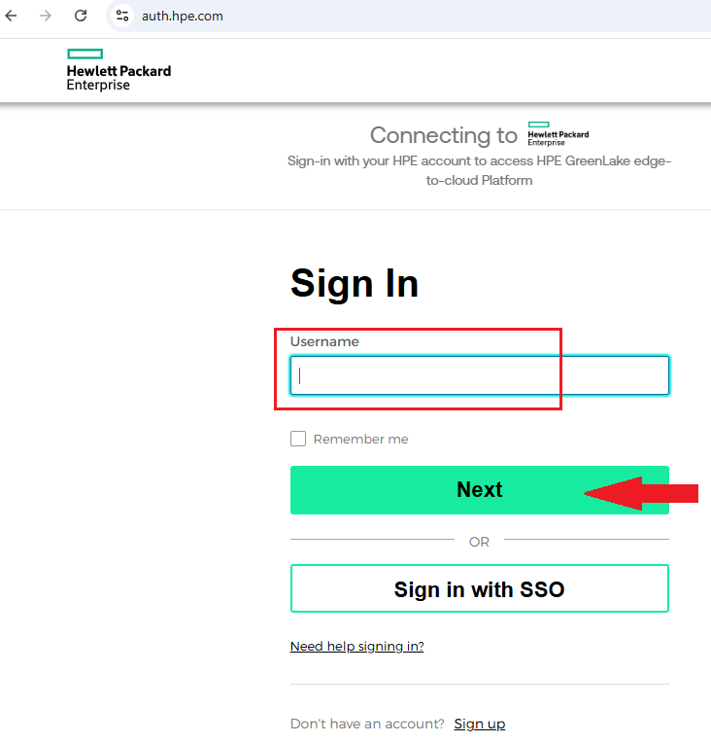

*Choose your workspace and go to the Data Services & Disaster Recovery service console:

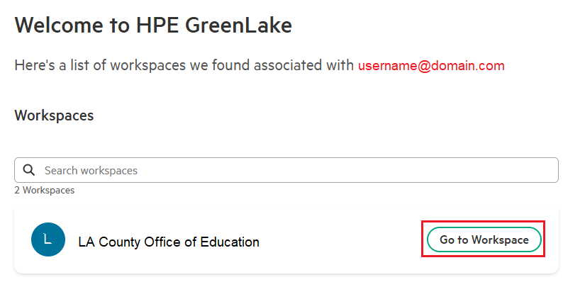

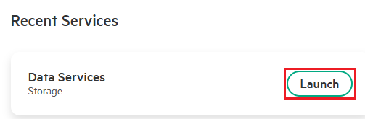

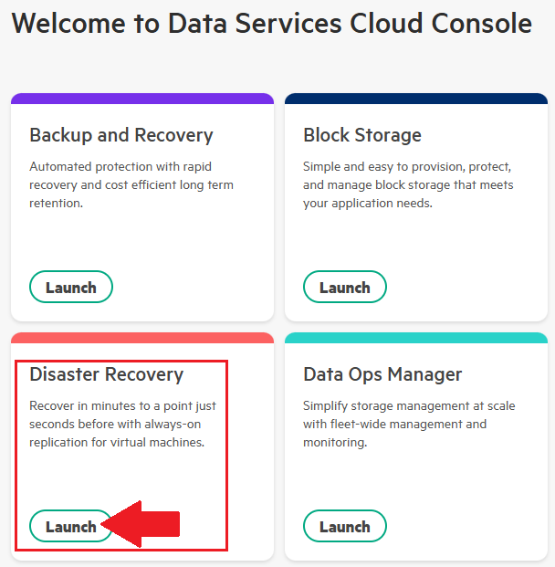

*Navigate to the Dashboard section and go to the vCenter VMAs area:

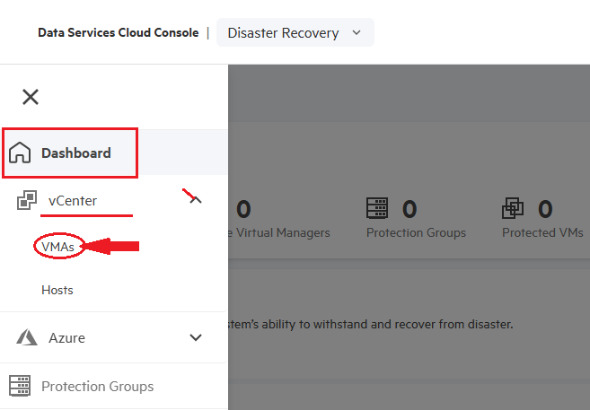

*Click on the “Download Manager” button as seen here to download the Virtual Manager Appliance:  
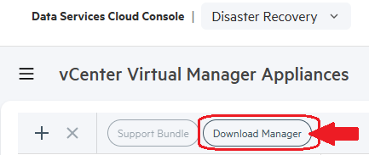

*Click the Download Package button:  
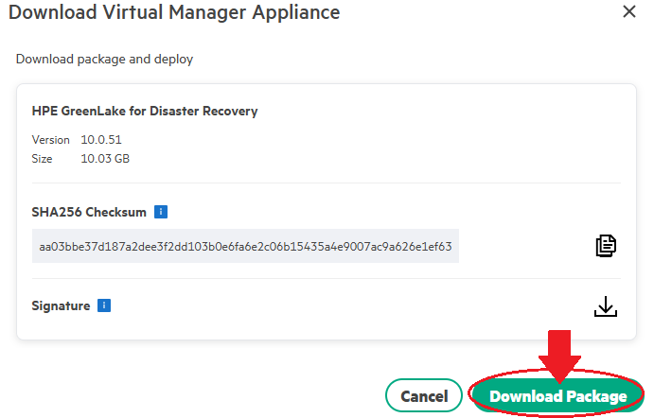

Once you have downloaded the Zerto VMA package, you can deploy it as a VM into vCenter from an OVF/OVA appliance file. Follow the ZVM Appliance Deployment instructions at this website: <https://help.zerto.com/bundle/Linux.ZVM.HTML.10.0/page/ZVM_Linux_Deployment_Guide.htm>

ZVM Appliance Post-Deployment Configuration:  
<https://help.zerto.com/bundle/Linux.ZVM.HTML.10.0/page/ZVM_Linux_Deployment_Settings.htm>

**Following the instructions above for deployment and post-deployment configuration, you will create a Zerto “Site” – this is a relationship defined when you connect the Zerto Virtual Replication Manager to a vCenter Server and its VM inventory. You can install and configure as many Zerto Sites as needed to fit your infrastructure, so long as you stay within the licensed VM count for active site-to-site replication groups.**

The ZVM is also the mechanism that allows you to deploy the next Zerto object – the “VRA”. The Zerto VRA is deployed to every physical ESXi host in the vCenter inventory where replication activity will be performed as a sender, a receiver, or both. The ZVM can deploy these appliances into the vCenter environment using a set of ports and protocols required for application functions. Please refer to the Firewall Appendix at the end of this document for details on the Firewall Port Requirements.

**Z-VRA**

Z-VRA replication appliances are deployed as lightweight VMs to ESXi hosts using the Zerto application’s web interface. These VRAs are responsible for sending & receiving VM replication traffic between host infrastructure at different sites (or within the same site if configured as such). Typical VRAs are only configured with 1 vCPU and 3 to 4 GB of vRAM on each host. They are also connected to a Network Port Group defined in the vCenter environment and available to the hosts for transferring VM replica data.

Consideration for which network segment will be used to transfer replica data between Zerto site resources is paramount to success. In most cases, an isolated network segment dedicated to replication traffic should be selected and used for this function. Beyond this function, you must also consider that the Zerto Manager (ZVM) for each site will need to send control data to the VRAs it manages across the same network segment – therefor, if you require separation between the replication network and the network where the ZVM UI is accessed by admin users, you will need to add a 2nd Virtual Network Adapter to the ZVM and attach it to the replication network where the VRAs will be connected. *NOTE – in the case of LACOE in this ERP deployment, *there is* ***no*** *separation* between the Mgmt UI network and replication network.

Resources for CPU and RAM assignments to VRAs can be adjusted and increased if they are going to be handling a large amount of replication traffic, but this is something you should only consider if RPOs and SLAs are failing due to the replication workload. Zerto Support should be contacted in those cases, and they would usually make recommendations to increase these when this scenario is encountered. Additional information about the Z-VRA Installation & Requirements is located here: <https://help.zerto.com/bundle/Linux.ZVM.HTML.10.0_U5/page/Installing_Virtual_Replication_Appliances.htm>

1. Installation & Configuration Details

This section of the report covers the breakdown of how the Zerto Components are configured – from the Site Managers and Replication Appliances to Virtual Protection Groups and Recovery Operations.

Currently, the LACOE BEST/ERP department has a Zerto implementation covering 2 sites – Downey (Production Site) and Coresite Los Angeles (DR Site). Each site has its own vCenter and Zerto VM managing the VM content in each location. Between both sites, there is a common replication network segment that Zerto uses for transmitting VM replica traffic. Here is an overall topology view:

Figure : Overall Zerto ERP Site Topology

Production Site: Zerto software version 10.0u5 was deployed in October 2024. This ZVM Site Manager was named “LCOMGT-ZVM101A” and is connected to vCenter v8 Server “LCOMG-VM101”.

DR Site: Zerto software version 10.0u5 was deployed in October 2024. This ZVM Site Manager was named “LCOMGT-ZVM201A” and is connected to vCenter v8 Server “LCOMG-VM201”.

* 1. Zerto Site Managers (ZVM) & Replication Appliances (Z-VRA)

Zerto Site Managers (ZVMs) were downloaded from the HPE Cloud resources website and deployed as VMs in the environments they are protecting at each location. During the planning phases, it was decided that the ZVMs and Z-VRAs would be deployed in the same network segment used for replication and a “jump box” VM would be used to reach the resources for admin/operational purposes. Below in Table 1 are the Zerto ERP division components deployed, and their relative networking resources assigned.

Table : Zerto Component Networking Assignments

|  |  |  |  |  |
| --- | --- | --- | --- | --- |
| **Zerto Site Manager (ZVM) Name** | **ZVM Physical Location** | **ZVM Mgmt IP Address** | **ZVM VRA Network** | **ZVM VRA IP Addresses** |
| LCOMGT-ZVM101A | Downey, CA (LCO Prod) | 10.245.22.150 (/22) | vlan 2020 | 10.245.22.151-162 |
| LCOMGT-ZVM201A | Los Angeles, CA (CoreSite DR) | 10.246.22.150 (/22) | vlan 2520 | 10.246.22.151-158 |

|  |  |  |  |  |
| --- | --- | --- | --- | --- |
| **Zerto Virtual Replication Appliance (Z-VRA) Name** | **Hypervisor Hosting Z-VRA** | **Z-VRA Site Location** | **Z-VRA Network Assignment** | **Z-VRA Network IP Address** |
| Z-VRA-DW1-ESX118 | dw1-esx118 | Downey, CA (LCO Prod) | DW1 VL2020 | 10.245.22.151 |
| Z-VRA-DW1-ESX119 | dw1-esx119 | Downey, CA (LCO Prod) | DW1 VL2020 | 10.245.22.152 |
| Z-VRA-DW1-ESX120 | dw1-esx120 | Downey, CA (LCO Prod) | DW1 VL2020 | 10.245.22.153 |
| Z-VRA-DW1-ESX121 | dw1-esx121 | Downey, CA (LCO Prod) | DW1 VL2020 | 10.245.22.154 |
| Z-VRA-DW1-ESX122 | dw1-esx122 | Downey, CA (LCO Prod) | DW1 VL2020 | 10.245.22.155 |
| Z-VRA-DW1-ESX123 | dw1-esx123 | Downey, CA (LCO Prod) | DW1 VL2020 | 10.245.22.156 |
| Z-VRA-DW1-ESX124 | dw1-esx124 | Downey, CA (LCO Prod) | DW1 VL2020 | 10.245.22.157 |
| Z-VRA-DW1-ESX125 | dw1-esx125 | Downey, CA (LCO Prod) | DW1 VL2020 | 10.245.22.158 |
| Z-VRA-DW1-ESX126 | dw1-esx126 | Downey, CA (LCO Prod) | DW1 VL2020 | 10.245.22.159 |
| Z-VRA-DW1-ESX127 | dw1-esx127 | Downey, CA (LCO Prod) | DW1 VL2020 | 10.245.22.160 |
| Z-VRA-DW1-ESX128 | dw1-esx128 | Downey, CA (LCO Prod) | DW1 VL2020 | 10.245.22.161 |
| Z-VRA-DW1-ESX129 | dw1-esx129 | Downey, CA (LCO Prod) | DW1 VL2020 | 10.245.22.162 |
| Z-VRA-DR1-ESX111 | dr1-esx111 | Los Angeles, CA (CoreSite DR) | DR1 VLAN 2520 | 10.246.22.151 |
| Z-VRA-DR1-ESX112 | dr1-esx112 | Los Angeles, CA (CoreSite DR) | DR1 VLAN 2520 | 10.246.22.152 |
| Z-VRA-DR1-ESX113 | dr1-esx113 | Los Angeles, CA (CoreSite DR) | DR1 VLAN 2520 | 10.246.22.153 |
| Z-VRA-DR1-ESX114 | dr1-esx114 | Los Angeles, CA (CoreSite DR) | DR1 VLAN 2520 | 10.246.22.154 |
| Z-VRA-DR1-ESX115 | dr1-esx115 | Los Angeles, CA (CoreSite DR) | DR1 VLAN 2520 | 10.246.22.155 |
| Z-VRA-DR1-ESX116 | dr1-esx116 | Los Angeles, CA (CoreSite DR) | DR1 VLAN 2520 | 10.246.22.156 |
| Z-VRA-DR1-ESX117 | dr1-esx117 | Los Angeles, CA (CoreSite DR) | DR1 VLAN 2520 | 10.246.22.157 |
| Z-VRA-DR1-ESX118 | dr1-esx118 | Los Angeles, CA (CoreSite DR) | DR1 VLAN 2520 | 10.246.22.158 |

The Zerto ZVM managing each site is a Debian Linux-based Appliance VM. By default, the SSH protocol is disabled for security reasons on these ZVMs. Accessing the ZVM console can be done by logging into vCenter and launching the VM Console. To access the main OS management menu, you must login to the machine console with the “zadmin” user account. Credentials have been recorded & secured by Jeff Rhey.

Launching the ZVM Web Console:  
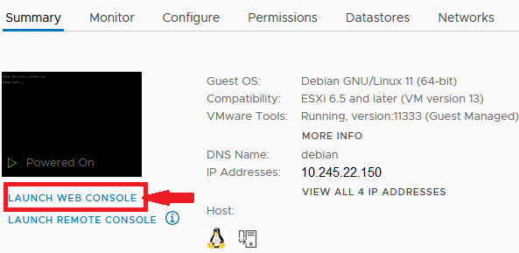

Login to the OS with “zadmin” user:  
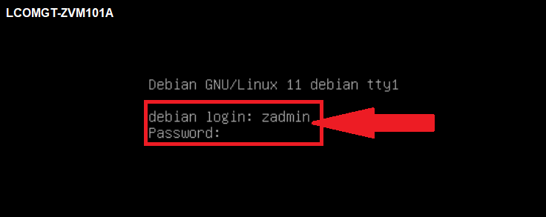

Select the management option from the Appliance Manager menu:  
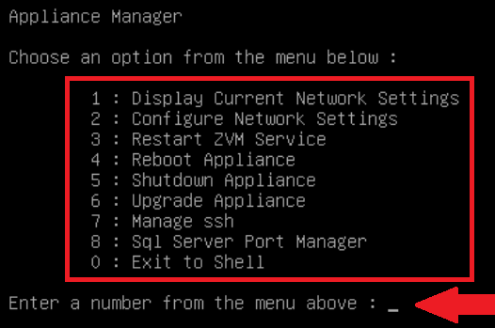

The options listed above in the ZVM Appliance Menu are self-explanatory, and if OS operations via command-line are needed, select the “0” option to “Exit to Shell”. Sample of the shell CLI:

**Zerto Site – Web Management UI**

VM Management Consoles are for simple appliance operations as detailed above. Accessing the Web UI from each ZVM is done through browsing to the correct site with a supported browser from a jump box.

*Managing the Production Site can be done navigating to <https://lcomgt-zvm101a.lacoe.edu:9669>   
*Managing the DR Site can be done navigating to <https://lcomgt-zvm201a.lacoe.edu:9669>

Login to the Web UI using the “admin” user credentials and click Sign In:

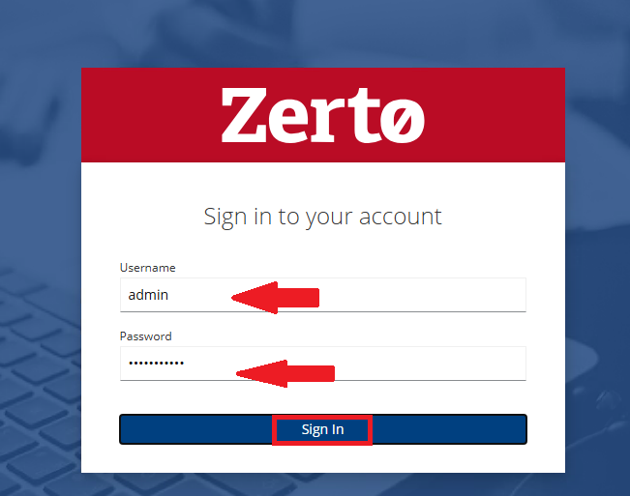

Once logged into the Zerto Site UI, you will see the primary dashboard and be able to navigate to the Sites, VPGs, VMs, Monitoring, Extended Journal, Reports, Analytics, Setup and Site Properties areas. There are also Failover, Restore and Move buttons.

Figure : Zerto Site Dashboard

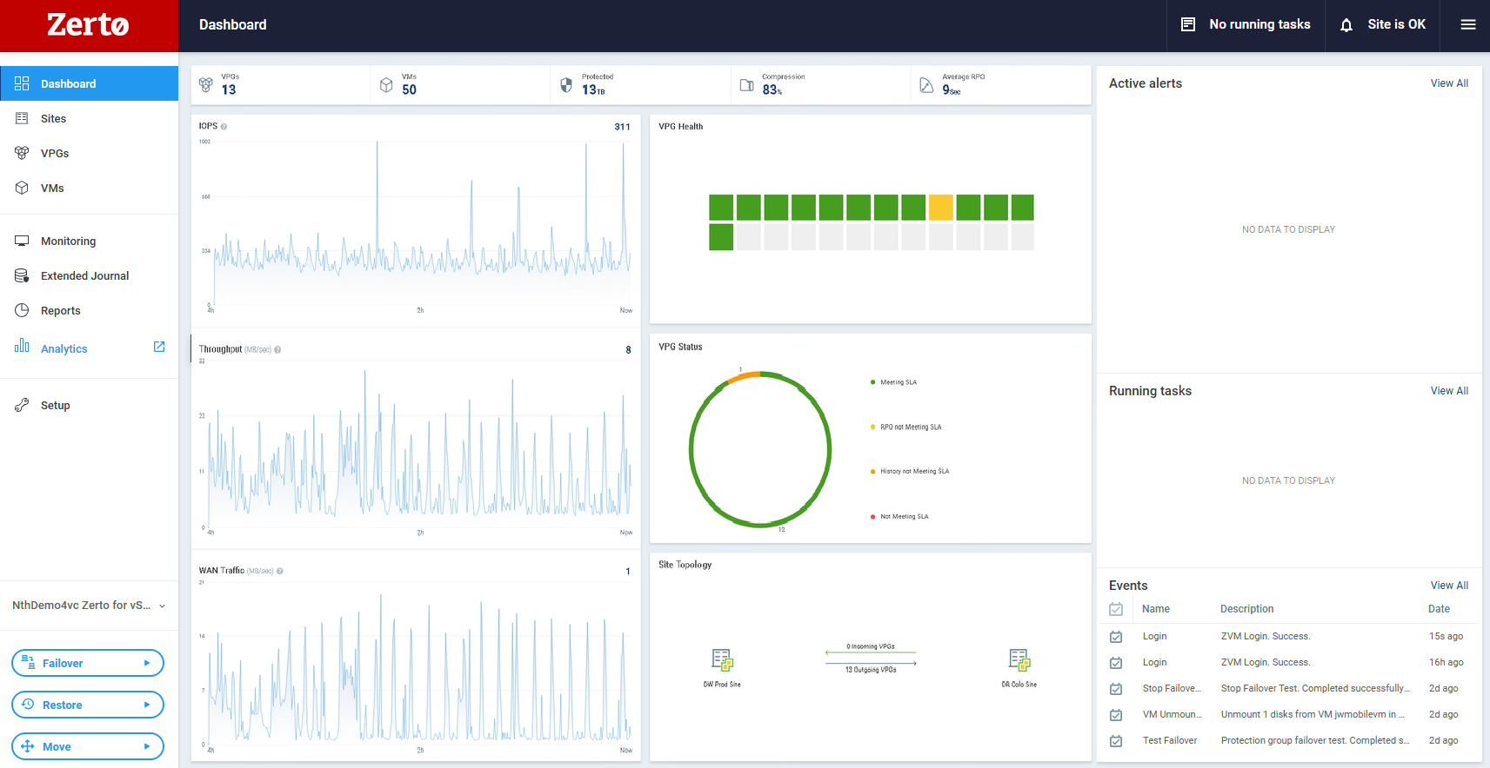

Shown above is the primary dashboard that displays overall activity and health of the Zerto environment. The activity and health displayed shows throughput and WAN traffic metrics between the site you’re logged in to and any other connected sites with established VPG replication. Once the ZVM has been deployed, the host-based VRA replication appliances are deployed & managed from this interface in the “Setup” section. When you click that area, the virtual infrastructure and deployed VRAs are displayed:

Figure : VRA Setup Dashboard

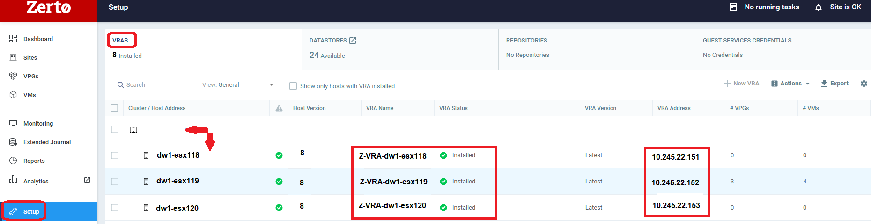

In the figure shown above, the Setup section is shown with the VRAs tab selected. This is a sample of how the environment replication appliances are listed in the Virtual Infrastructure. VMware Hosts are shown and if they have a VRA installed, it shows the VRA objects, and the IP addresses assigned to each VRA.

VRA machines can be edited to alter IP address, vCPU and vRAM assignments if needed. Each VRA should be pinned to the relative host server and always reside there – when host maintenance is performed, the VRA machine should be shut down prior to rebooting the related host server.

VRAs (Virtual Replication Appliances):  
<https://help.zerto.com/bundle/Linux.ZVM.HTML.10.0_U5/page/Installing_Virtual_Replication_Appliances.htm>

* 1. Zerto Site Component Maps

Below we have placed a copy of the site component drawings to depict connections etc.

Figure : Production Site Zerto Map

Figure : DR Site Zerto Map

Essentially, Zerto Sites are comprised of the Zerto Manager (ZVM), its attachment to a vCenter Server and the inventory within the vCenter environment. Components above are shown with their relationship to the other objects in each site and what networking/storage is connecting/housing them.

* 1. Virtual Protection Groups (VPG)

Virtual Machines are replicated via the Zerto VPG object – the VPG is a grouping of one or more VMs with settings defined for replication & failover. VPG replication can be done within one site or between sites. All VPG items documented herein for LACOE ERP division are between 2 sites. Options for VMs defined in a VPG are their preferred boot order (if any order is desired), the target site network & storage resources, journaling behavior, any exceptions or overrides, failover and test behavior, scripting options, and desired RPO/SLA metrics.

The following 13 VPGs were created during the Zerto deployment with LACOE ERP/BEST division. Data on all 50 VM members, boot order and storage sizing are captured here.

Figure : VPG Appendices

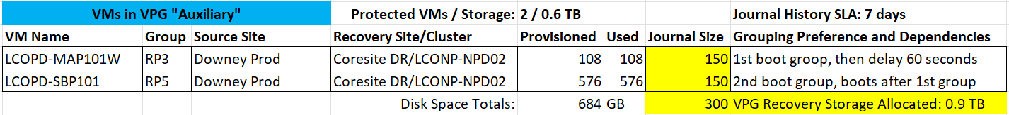

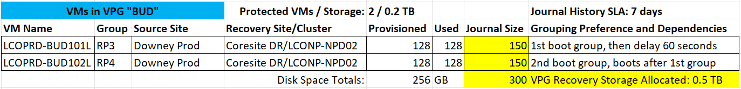



**-VPG FAILOVER-**

\**The process for a VPG failover can be done “****Live****” or in “****Test****” mode.*  
When a VPG failover is triggered in **Live mode**, the Zerto software conducts automated tasks with a set of options depending upon the scenario. For example – if the failover is triggered from the VPG Target Site while both sites are still up and reachable, you can select the option to shut down the source VMs prior to enabling the replica target VMs. This would be considered a graceful/planned failover. However – if the VPG Source Site is down, disconnected and/or unreachable, triggering a failover from the VPG Target Site will not be able to automate the source VM shutdown process, and the failover will simply register the replica VMs and power them on as configured. This should be understood to avoid unintentional conflict with any coexisting VM resources (name and IPs, etc.) – if you must, the original source VMs should be powered off when replica target VMs are brought online.

Reverse Replication can be triggered if a graceful/planned failover is done intentionally and replication back to the source site going forward is desired. This scenario obviously requires both sites to be up/reachable.

Failover **Test mode** operations can be done at any time with no impact to production systems or ongoing VPG replication. With the proper configuration applied, VPG Failover Tests will create a copy of replica VMs from checkpoints available at the VPG Target Site. These replica VMs will then be registered with the vCenter inventory and be powered on in the target host, networking and storage environment. As long as the Failover Test Networking is used with all VM NIC adapters, the VM network traffic will be isolated to the VLAN in the connected port group and unable to communicate with production VLANs.

During a Failover Test operation, the VM replicas from the VPG will remain powered on for admins to use in test scenarios until the “stop” button is triggered. Once the test is stopped with the Zerto UI, admin team members can select a test outcome (failed, successful, etc) and write comments and notes into the stop operation window. Stopping a Failover Test will automatically shut down all replica VMs used in the test and un-register them from the target site’s vCenter inventory.

**Failover Reports:** Reporting can be generated after a VPG Live or Test Failover is conducted that gives time stamps and a list of objects triggered during the failover. Any outcomes and notes will also be included in the report. This can be done from the Zerto Site UI in the Reports pane as seen here:  
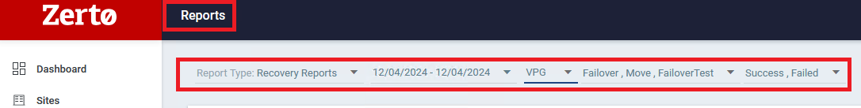

**-VPG FAILOVER WORKFLOW-**

Below is a diagram that outlines the general steps to be performed when doing a VPG Failover and Failback between sites.

Figure : VPG Failover Workflow

* 1. Next Steps for LACOE: A Call-to-Action Summary

Overall, Nth recommends the following steps

1. If not already enabled, consider adding SMTP email services to each Zerto Site Manager to keep your team informed of any issues that may pop up in the Zerto sites with RPO or other items.
2. Consider conducting regular VPG failover testing exercises that will match outage scenarios defined in a Business Continuity Plan.
3. Always keep a spreadsheet updated with the Zerto VPG members and the required storage space, RAM and CPUs required to run the replicas at the DR Site in case of an outage. This will help ensure you have enough resources for current and future needs as the environment changes.
4. After the temporary 3PAR Datastore Cluster is no longer the desired target for some of the VPG replication, you will need to reconfigure the VPGs to replicate to a different Datastore Cluster at the DR Site. Don’t forget to prepare the alternate storage location with enough space to house the replicas and journal histories.
   1. If you have any questions, concerns, or would like guidance when it comes time to make these changes, feel free to reach out to Nth so we can help you accomplish this.
5. Please review this documentation and any other documents Nth created that are intended to assist your team with the Zerto implementation. If there are any discrepancies or changes needed, please contact Jason Walker @ Nth to let us know and we can resolve this with your team.
6. Reference Links

This section contains a large set of useful links to Zerto references that Nth Generation analysts will typically use to configure & maintain Zerto environments.

Zerto Solution Architecture:  
<https://help.zerto.com/bundle/Admin.VC.HTML.10.0_U5/page/The_Zerto_Solution_Architecture.htm>

How Zerto Recovery Works:  
<https://help.zerto.com/bundle/Admin.VC.HTML.10.0_U5/page/How_Zerto_Recovery_Works.htm>

Zerto v10.0 U5 Release Notes:  
<https://help.zerto.com/bundle/RN.HTML.10.0_U5/page/release_notes_for_zerto_10_0_update_5.html>

ZVM Appliance Requirements:  
<https://help.zerto.com/bundle/Linux.ZVM.HTML.10.0_U5/page/Book_in_Portal_-_Prerequisite_for_ZVM_Linux.htm>

ZVM Appliance Deployment:  
<https://help.zerto.com/bundle/Linux.ZVM.HTML.10.0/page/ZVM_Linux_Deployment_Guide.htm>

ZVM Appliance Post-Deployment Configuration:  
<https://help.zerto.com/bundle/Linux.ZVM.HTML.10.0/page/ZVM_Linux_Deployment_Settings.htm>

ZVM Appliance Manager Menu:  
<https://help.zerto.com/bundle/Linux.ZVM.HTML.10.0_U5/page/ZVM_Linux_Appliance_Menu.htm>

VRAs (Virtual Replication Appliances):  
<https://help.zerto.com/bundle/Linux.ZVM.HTML.10.0_U5/page/Installing_Virtual_Replication_Appliances.htm>

VRA Installation Requirements:  
<https://help.zerto.com/bundle/Linux.ZVM.HTML.10.0_U5/page/VRA_Installation_Requirements.htm>

VRA Deployment:  
<https://help.zerto.com/bundle/Linux.ZVM.HTML.10.0_U5/page/Installing_a_Zerto_Virtual_Replication_Appliance_VRA_on_a_Host.htm>

Zerto for vSphere – Admin Guide:  
<https://help.zerto.com/bundle/Admin.VC.HTML.10.0_U5/page/Introduction_to_the_Zerto_Solution_on_vSphere.htm>

Creating & Managing Virtual Protection Groups (VPGs):  
<https://help.zerto.com/bundle/Admin.VC.HTML.10.0_U5/page/ProtectingVirtualMachinesfrom.htm>

<https://help.zerto.com/bundle/Admin.VC.HTML.10.0_U5/page/Replication_From_a_Protected_Site_vCenter_Server_to_a_Recovery_Site_vCenter_Server.htm>

<https://help.zerto.com/bundle/Admin.VC.HTML.10.0_U5/page/Configuring_Virtual_Protection_Groups.htm>

<https://help.zerto.com/bundle/Admin.VC.HTML.10.0_U5/page/Managing_VPGs.htm>

VPG Test Failover Process:  
<https://help.zerto.com/bundle/Admin.VC.HTML.10.0_U5/page/The_Test_Failover_Process.htm>

Zerto Known Issues:  
<https://help.zerto.com/bundle/Known.Issues.HTML/page/known_issues.html>

Zerto in VMware High Availability – Best Practices:  
<https://help.zerto.com/bundle/BP.HA.FOCluster.HTML/page/VMware_Clusters.htm>

vSphere Privileges Required:  
<https://help.zerto.com/bundle/Linux.ZVM.HTML.10.0_U5/page/vSphere_Privileges_Required_by_Zerto_Virtual_Replication.htm>

Appliance Password Resets:  
<https://help.zerto.com/bundle/Linux.ZVM.HTML.10.0_U5/page/ZVM_Appliance_Reset_Password.htm>

DNS Target Ports:  
<https://help.zerto.com/bundle/Linux.ZVM.HTML.10.0_U5/page/DNS_Targets_Ports.htm>

1. Zerto Glossary

Due to the number of technical terms, abbreviations and references given in this document, Nth has included a set of Glossary Terms for team reference as needed.

Zerto terms and other Data Protection standard terms used in this report are defined below.

A to Z industry terms used: <https://www.zerto.com/resources/a-to-zerto/>

Zerto-specific terms used: <https://help.zerto.com/bundle/Admin.VC.HTML/page/Glossary_VC.htm>